Autumn Two

Heather Garth FS2 Songs and Rhymes Book



**Our Welcome Songs**

Hello everyone, hello everyone, glad that you are here,

Hello everyone, hello everyone, glad that you are here,

I, I, I, I, I’m, glad that you are here,

I, I, I, I, I’m, glad that you are here!

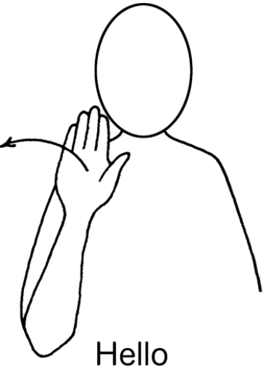

**A Song for Diwali**

(To the tune of Twinkle, Twinkle)

It’s Diwali, festival of light,

All the divas twinkle in the night!

Salmubarak – Happy New Year!

We’re so happy Diwali is here!

It’s Diwali, festival of light,

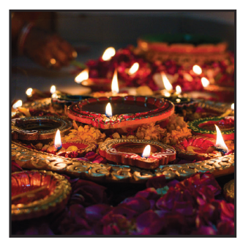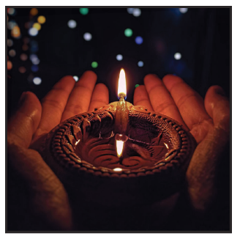All the divas twinkle in the night!

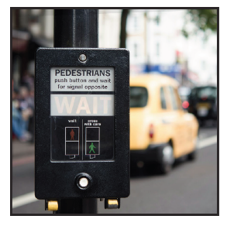

**Stop, Look, Wait**

Stop, look, wait.

Stop, look wait.

Before you cross the road,

before you cross the road.

We use our eyes and we use our ears and if no car or bus appears,

Well then, we cross the road, well then, we cross the road.

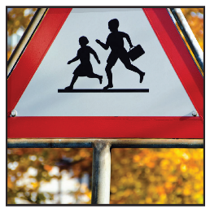

**Ten green bottles hanging on the wall**

TEN green bottles hanging on the wall,

TEN green bottles hanging on the wall,

And if one green bottle should accidentally fall,

There’ll be…

NINE green bottles hanging on the wall…

EIGHT green bottles hanging on the wall…

SEVEN green bottles hanging on the wall…

SIX green bottles hanging on the wall…

FIVE green bottles hanging on the wall…

FOUR green bottles hanging on the wall…

THREE green bottles hanging on the wall…

TWO green bottles hanging on the wall…

ONE green bottle hanging on the wall…

NO green bottles hanging on the wall!

**Ten fat sausages**

Ten fat sausages sizzling in the pan.

One went pop, and the other went bang!

Eight fat sausages sizzling in the pan.

One went pop, and the other went bang!

Six fat sausages sizzling in the pan.

One went pop, and the other went bang!

Four fat sausages sizzling in the pan.

One went pop, and the other went bang!

Two fat sausages sizzling in the pan.

One went pop, and the other went bang!



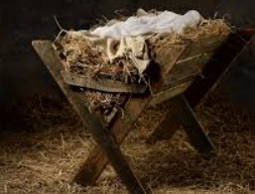**In a little stable**

In a little stable  
Far across the sea  
Was a little baby  
Just like you and me.

A bed or cradle,  
Not a pillow deep,  
But a lowly manger  
Was His place to sleep.

Shepherds stood around Him,  
Angels watched with care,  
For this babe was Jesus,  
Lying, smiling there.

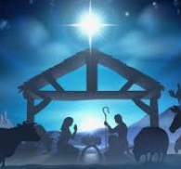Oh, I love this Jesus,  
Who was little then.  
For he surely loves me,  
Little though I am.