Heather Garth Langar Menu

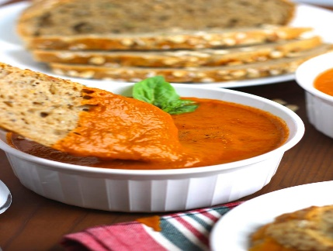

Starter:

“Gracious Gift.” {tomato and basil soup with seasoned bread.}

“Special salad.” {sliced lettuce,

cabbage, tomatoes and varied sauces.}

Main:

“Veggie surprise curry.” {tasty, curry that will blow your taste buds away.}

“veggie pillow “{blown up chapati with vegetables inside.}

“Fruity tooty blast”(amazing fruity yoghurt). Ben and Harvey

Fruity- tooty blast: (Amazing fruit yoghurt)

[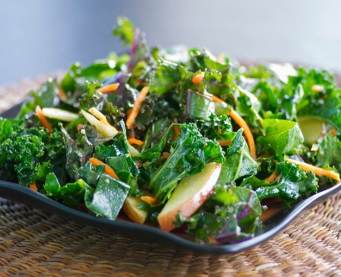](https://www.google.co.uk/url?sa=i&url=https%3A%2F%2Fwww.npr.org%2F2011%2F03%2F16%2F134564793%2Fraw-greens-apple-and-carrot-salad-with-warm-maple-mustard-vinaigrette&psig=AOvVaw3kx2xAld2sqa8LMNX6RC7m&ust=1584098560558000&source=images&cd=vfe&ved=0CAIQjRxqFwoTCMidwb_plOgCFQAAAAAdAAAAABAc)

[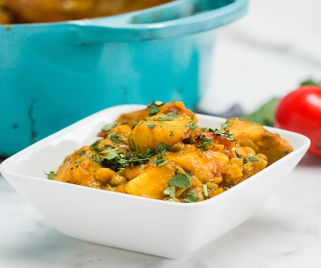](https://www.google.co.uk/url?sa=i&url=https%3A%2F%2Ftasty.co%2Frecipe%2Fsimple-veggie-curry&psig=AOvVaw1tyeD-xipc0BHvBwkj0NQM&ust=1584098773852000&source=images&cd=vfe&ved=0CAIQjRxqFwoTCIDMq6XqlOgCFQAAAAAdAAAAABAE)

