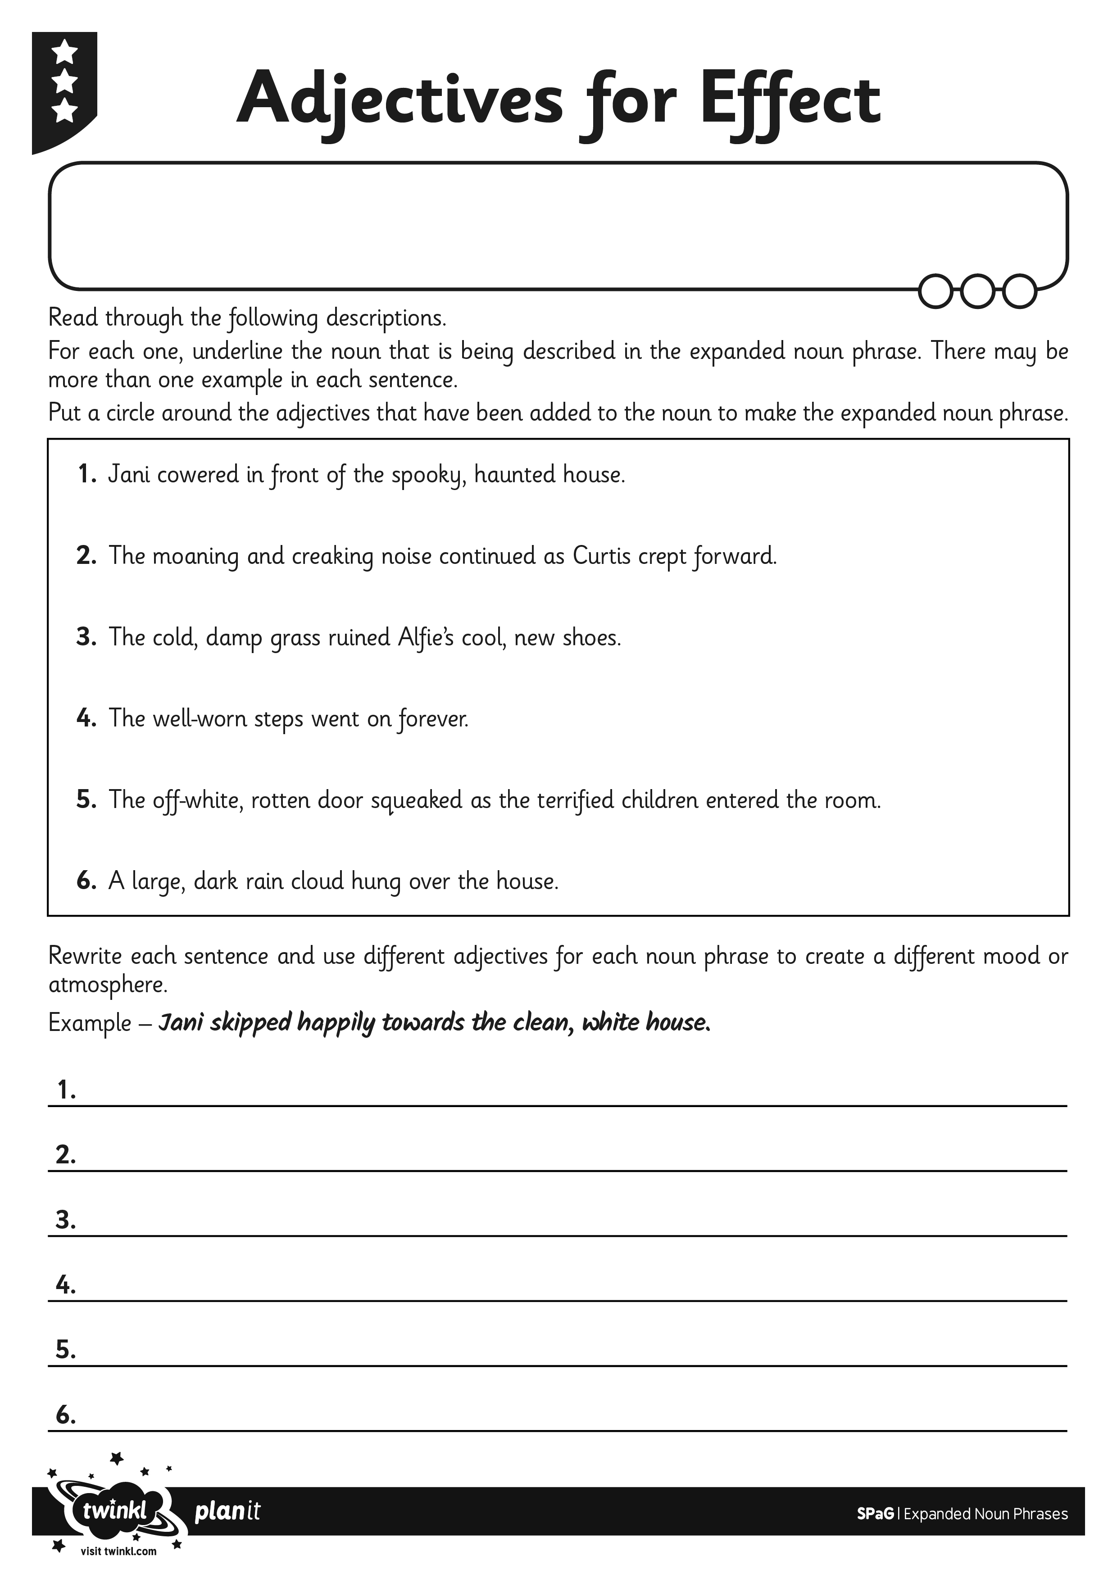
I can expand a simple noun phrase.

